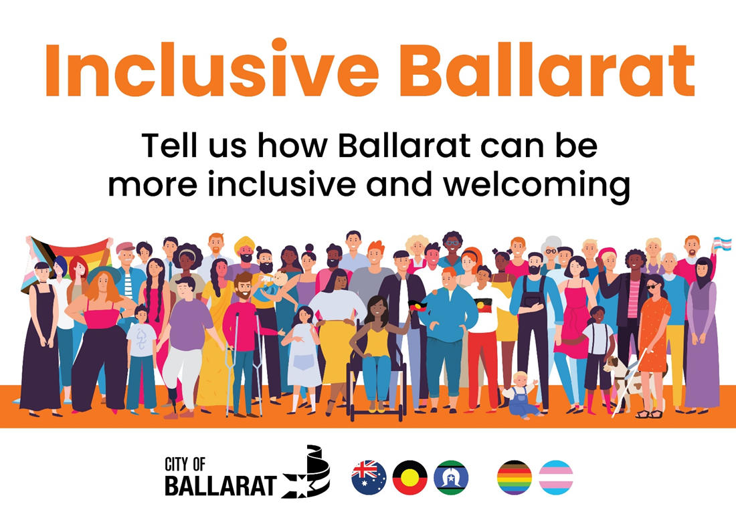

Easy to Read Version April 2022
This book has some hard words. The first time we write a hard word the word is in blue and we write what the hard word means.
You can get someone to help you to
- Read this book
- Understand this book
- Find out more information at City of Ballarat.

This book is written by City of Ballarat. City of Ballarat is the local council for the Ballarat area. When you see the word ‘we’ or ‘council’ it means City of Ballarat.

Introduction
This book is about how council will listen to your feedback.
Feedback is when people share their ideas. We want to know what council can do to make Ballarat the best place it can be.
We will listen to you from 11 April to 8 May 2022. You can tell us your ideas at other times too.

Why do we want feedback?
Council wants feedback
- To understand what is important to you.
- To make plans. Plans are documents that tell us what we will do to make things better.
How can I give feedback?
Council wants you to tell us what you want. You can tell us how to make Ballarat better for you.
You can choose one or more ways to tell us.

You can visit a website
A website is a page on a computer that you can visit for information. This is the website you can visit
https://mysay.ballarat.vic.gov.au/inclusive-ballarat.

You can fill in a survey
A survey is a list of questions you can answer on the computer or on paper.
You can fill in the survey on the website https://mysay.ballarat.vic.gov.au/inclusive-ballarat/survey_tools/how-do-we-make-ballarat-more-inclusive-for-everyone.

Or you can call us to complete it over the phone.

You can tell us your ideas in other ways by visiting the website.

You can look at the Quick Poll
A quick poll shows you a question or statement. It asks you to vote. A vote is when you choose the answer that is right for you.

You can tell us on a map.
A map is a picture of an area including streets and parks. You can move the pink pin on the map. You can put more than one pin on the map. You can move a pin to where you
- Feel safe
- Can access the place easily. Access means that you can get there and move around safely.

You can write or draw your ideas using an activity sheet
An activity sheet is a page telling you what to draw or write about.
You can print out the activity sheet or use a piece of paper.

You can tell us by having a Community Conversation
A Community Conversation is a meeting where you can talk with other people about your ideas. You can talk to friends or family members, workers or people you trust.

The questions are in the Conversation Kit. The Conversation Kits are on the right side of the website. Open up the document for information.

You can answer the questions
- On an online form. The link for the online form is in the Conversation Kit.
- On paper. You can collect this from the library. You write the answers on the paper. Return it to the library or in the mail.
You can
- list one idea.
- list lots of ideas.
- include ideas from different people all together.
- choose the conversation you want to have from
  - Inclusion for everyone
  - People with disability
  - People from different cultures
  - People from LGBTIQA+ communities.

You can contact Council to tell us your ideas. You can use the telephone to talk to us. You can ask for help. You can visit the Phoenix Building.

What can you talk about?
You can tell us about any ideas you have. We want to hear from lots of different people.
You might be asked
- If Ballarat is an inclusive place. Being inclusive means that everyone feels like they belong. That everyone is important. That everyone can take part in activities.
- If you have any ideas for making Ballarat more inclusive.
- How you find out about events.
- How you like to find out information. Information is something that people can learn, know about, or understand.
- Ideas about working or being a volunteer at Council. A volunteer is someone who does work because they want to but is not paid.
- Ideas for making buildings more inclusive and accessible. Accessible means that you can go inside the building, move around and join in activities.
- Other questions such as if you have a disability or your age.

What will we do with your feedback?
We will listen to your ideas. We will take notes. We will put together all ideas. This will help us to make plans for the next four years. You can look at the plans if you want to.

Contact us
If you have questions about this book contact Bernadette Duffy

Phone - 5320 5500

Email - bernadetteduffy@ballarat.vic.gov.au

Mail to
Community Engagement
City of Ballarat
Wadawurrung Country
PO Box 655, Ballarat 3353.

Website - https://mysay.ballarat.vic.gov.au
Visit
The Phoenix, 25 Armstrong Street South, Ballarat.

National Relay Service
TTY 133 677
Then ask for 5320 5500.

Speak and Listen 1300 555 727
Then ask for 5320 5500.

Internet relay users connect to the NRS
Then ask for 5320 5500.

Meanings
Access means that you can get there and move around safely
Accessible means that you can go inside the building, move around and join in activities
Activity sheet is a page telling you what to draw or write about
City of Ballarat is the local council for the Ballarat area
Community Conversation is a meeting where you can talk with people about your ideas
Feedback is when people share their ideas
Inclusive means that everyone feels like they belong. That everyone is important. That everyone can take part in activities.
Information is something that people can learn, know about, or understand
Map is a picture of an area including streets and parks
Plans are documents that tell us what we will do to make things better
Quick Poll is a question or statement to answer
Survey is a list of questions you can answer on the computer or over the phone
Volunteer is someone who does work because they want to but is not paid
Vote is when you choose the answer that is right for you
Website is a page on a computer or your phone that you can visit for information

