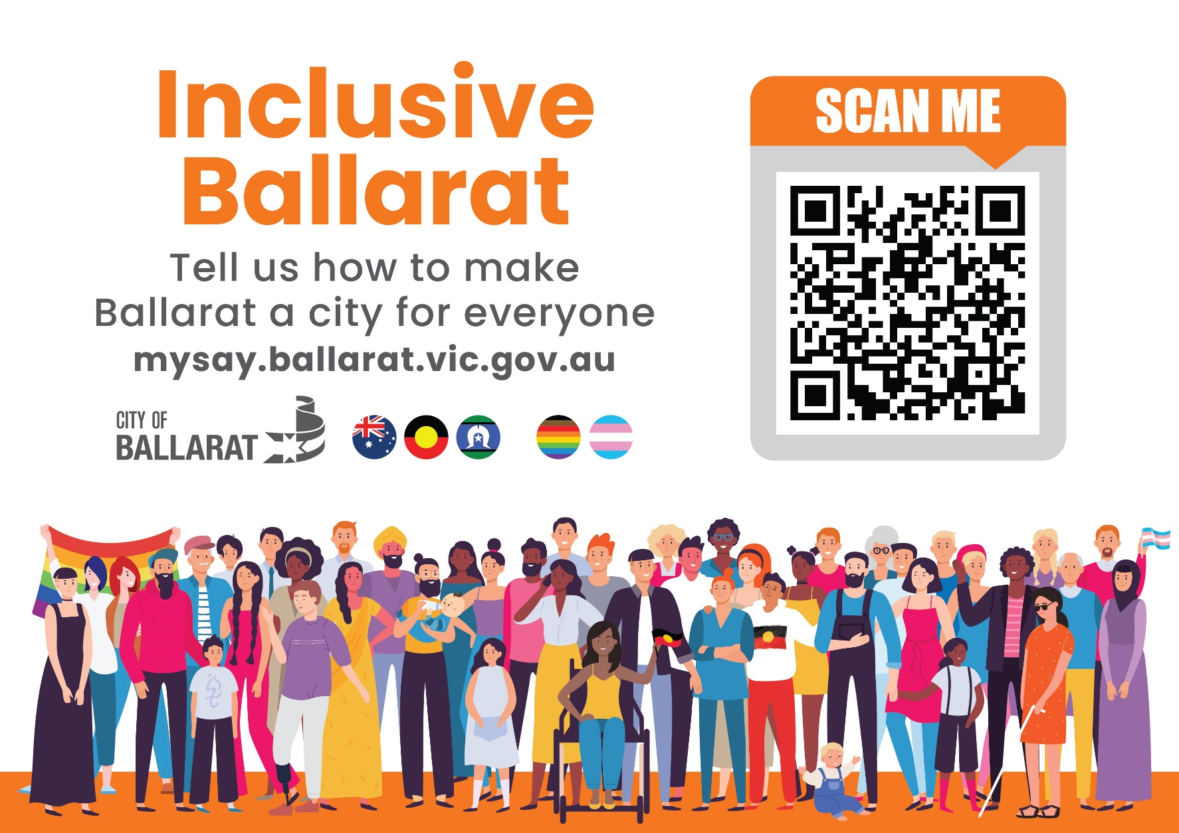

**Inclusive Ballarat**

**Inclusion Framework and Plans**

Community Feedback



**Easy to Read Version August 2022**

This book has some hard words.

The first time we write a hard word

* the word is in **blue**
* we write what the hard word means

You can get someone to help you

* Read this book
* Understand this book
* Find out more information at City of Ballarat

This book is written by **City of Ballarat**.

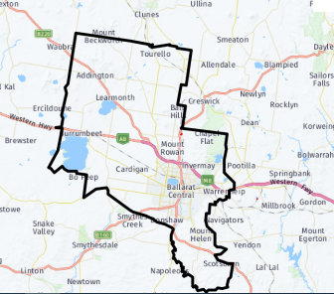City of Ballarat is the local council for the Ballarat area.

When you see the word ‘we’ or ‘council’ it means City of Ballarat.

# **Introduction**

This book is about how council will listen to your **feedback.**



Feedback is when people share their ideas. We want to know what you think about our **plans**.

* Plans are documents that tell everyone what we will do to make things better

We will listen to your feedback from 25 August to 21 September 2022.

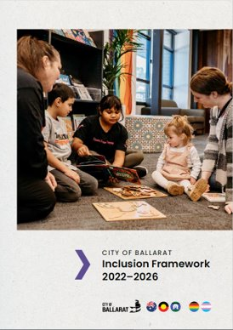**What are the plans about?**

 We have an **Inclusion Framework**

The Inclusion Framework is a plan that says what we will do to make Ballarat a place for everyone to enjoy.

There are also other plans to help different groups of people to join in.

This includes the

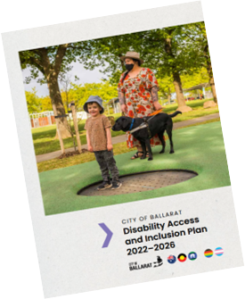Disability **Access** and **Inclusion** Plan

* + Access means that you can get there and move around safely
  + Inclusion means that everyone feels like they belong. That everyone is important. That everyone can take part in activities.

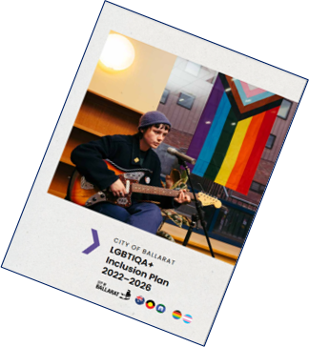**LGBTIQA+** Inclusion Plan

* + Sometimes LGBTIQA+ people might use a rainbow flag
  + Sometimes people who support them use a rainbow flag too
* LGBTIQA+ stands for Lesbian, Gay, Bi- Questioning and Asexual.

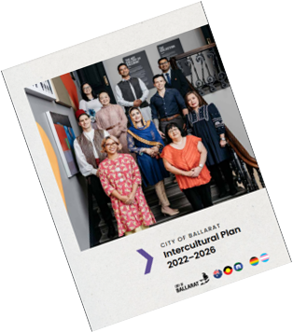**Intercultural** Communities Plan

* Intercultural means when people from different backgrounds or cultures work together

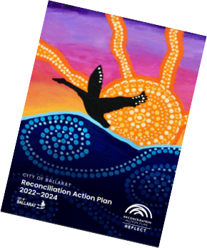**Reconciliation** Action Plan

* Reconciliation is about building trust and respect
* It is about learning from **First Nations** people and about the past
* 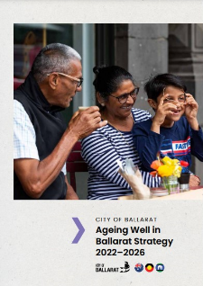First Nations people in Australia are Aboriginal and Torres Strait Islander Peoples

**Ageing** Well Strategy

* Ageing means getting older.
* This plan is mostly about people who are over 50 years of age

**Why does Council want feedback?**

Council wants feedback to find out

* + if the plans are good
  + if we missed anything important

**How can I give feedback?**

Council wants you to tell us what you think about the plans. You can tell us if we have missed something.

You can choose one or more ways to tell us

* Visit a **website**

A website is a page on a computer that you can visit for information

This is the website you can visit

<https://mysay.ballarat.vic.gov.au/city-of-ballarat-inclusion-documents>

You can look at the plans on this website



Fill in a **survey**

A survey is a list of questions you can answer on the computer or on paper

You can fill in the survey on the website

Or you can collect a paper survey at

* The library
* The Phoenix Building

25 Armstrong Street South

Ballarat

* Tell us at a **Snack and Chat**

A Snack and Chat is a meeting you can go to so you can tell people your feedback. You do not have to book in.

You can

* choose the one you want to go to
* stay for some of the time
* look at the plans
* ask questions
* write your feedback down or tell someone
* have something to eat there

You can visit a Snack and Chat on

* **Tuesday 30 August from 11am - 1pm** at Ballarat Regional Multicultural Council at Barkly Square in Ballarat East
* **Thursday 1 September from 3pm – 4.30pm** at Sebastopol Library
* **Thursday 8 September from 3.30pm - 5pm** at Ballarat North Community Centre
* **Thursday 15 September from 4.30pm - 6pm** at Sebastopol Library
* Contact council to tell us your feedback

You can use the telephone to talk to us

You can visit the Phoenix Building

You can write a letter

**What feedback can you give us?**

You can tell us

* If the plans are easy to understand
* If you like the plans
* If you don’t like the plans
  + Any ideas you have about how we can make the plans better

**What will we do with your feedback?**

We will listen to your feedback

We will take notes

We will put together all feedback

This will help us to make the plans better

**Contact us**

If you have questions about this book contact

Bernadette Duffy, Community Inclusion Officer



**Phone**

5320 5500



**Email**

[bernadetteduffy@ballarat.vic.gov.au](mailto:bernadetteduffy@ballarat.vic.gov.au)

**Mail**

City of Ballarat

Community Inclusion Officer

PO Box 655, Ballarat 3353

**Website**

<https://mysay.ballarat.vic.gov.au>

**Visit**

The Phoenix

25 Armstrong Street South

Ballarat

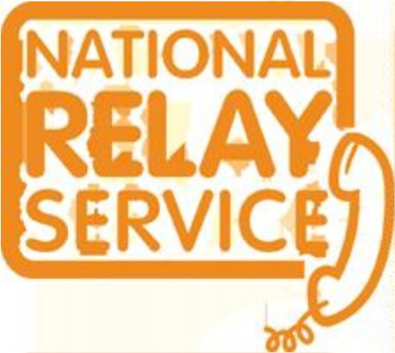

**National Relay Service**

**TTY** 133 677

Then ask for 5320 5500

**Speak and Listen** 1300 555 727

Then ask for 5320 5500

**Internet relay users connect to the NRS**

Then ask for 5320 5500

**Meanings**

**Access** means that you can get there and move around safely

**Ageing** means getting older. It is mostly used for talking about people who are over 50 years of age

**City of Ballarat** is the local council for the Ballarat area

**Feedback** is when people share their ideas

**First Nations** people in Australia are Aboriginal and Torres Strait Islander Peoples

**Inclusion** means that everyone feels like they belong. That everyone is important. That everyone can take part in activities.

**Inclusion Framework** is a plan that says what we will do to make Ballarat a place for everyone to enjoy

**Intercultural** means when people from different backgrounds or cultures work together

**LGBTIQA+** stands for Lesbian, Gay, Bi-sexual, Transgender, Intersex, Queer or Questioning and Asexual

**Plans** are documents that tell everyone what we will do to make things better

**Reconciliation** is about building trust and respect. It is about learning from First Nations people and about the past

**Survey** is a list of questions you can answer on the computer or on paper

**Website** is a page on a computer or your phone that you can visit for information