Planning and Environment Act 1987

BALLARAT PLANNING SCHEME

AMENDMENT C240ball

EXPLANATORY REPORT

Who is the planning authority?
This amendment has been prepared by the Ballarat City Council who is the planning authority for this amendment.
The amendment has been made at the request of the Ballarat City Council.

Land affected by the amendment
The land affected by the amendment includes six individual properties across Ballarat, including:
- 89 Magpie Street, Golden Point (CA 2 Sec 119A)
- 1207 Winter Street, Buninyong (CA 109)
- 201 Melbourne Road, Brown Hill (Pt CA 13 Sec 210)
- 618 Howitt Street, Ballarat North (CP174069)
- 742 Geelong Road, Canadian (CA 14C Sec 14)
- 113 Lovfen Street, Nerrina (CA 26 Sec AA)

The amendment also applies to the Holmes Street Residential Precinct, comprising of 7,9,11,13,15,17,19 Holmes Street, Ballarat Central (Lot 10 LP3940, Lot 1 TP746776, Lot 1 TP101715, Lot 1 TP689192, Lot 1 TP689227, Lot 1 TP698127, Lot 3 LP3940), including the road reserve.

A mapping reference table is attached at Attachment 1 to this Explanatory Report.

What the amendment does
The amendment applies the Heritage Overlay to five individual heritage sites and one residential precinct known as Holmes Street Residential Precinct found to be of local heritage significance in Ballarat. It also makes administrative changes to remove an expired interim Heritage Overlay for the heritage place ‘Former Eureka Lead Gold Sluicing Company Pumping Site’ that no longer exists.

Specifically, the amendment:
- Amends the Schedule to Clause 43.01 (Heritage Overlay) to:
  - Apply the Heritage Overlay to:
- ‘Victory’ house at 742 Geelong Road, Canadian (HO226)
  - Including tree controls for the mature Cypress hedges.
- ‘Bournedale’ Selkirk house and garden at 618 Howitt Street, Ballarat North (HO227)
  - Including tree controls for all mature specimen trees, shrubs and Palms and Privet hedge. External paint controls apply to the front porch including the doors, screen doors, pictorial window and ceiling strapping. The brick fence, pedestrian and vehicle gates are not exempt under Clause 43.01-4.
  - Miner’s Right/John Pearce House at 89 Magpie Street, Golden Point (HO228)
- Mossmont House and Garden at 1207 Winter Street, Buninyong (HO229)
  - Including tree controls for the mature specimens of Elm (Ulmus sp.), Tulip Tree (Liriondendron tulipifera), Flowering plum trees (Prunus sp.), Hawthorns (Cratageus sp.) and Holly (Ilex aquifolium). The brick building on the south side of the house is not exempt under Clause 43.01-4.
- St Marks Anglican Parsonage at 201 Melbourne Road, Brown Hill (HO230)
  - Including tree controls for the mature Dutch Elm (Ulmus x hollandica) and English Oaks (Quercus robur).
- ‘Holmes Street Residential Precinct’, Ballarat Central (HO231)
• Delete expired interim heritage control known as HO224 that relates to the former Eureka Lead Sluicing Shed at 113 Lofven Street, Nerrina.
- Amends the Schedule to Clause 72.04 - Documents Incorporated in this Planning Scheme to include the Statement of Significance for each heritage place as an Incorporated document, including:
  - ‘Victory’ House Statement of Significance (City of Ballarat, May 2023)
  - ‘Bournedale’ Selkirk House and Garden Statement of Significance (Landmark Pty Ltd., May 2023)
  - Miner’s Right/John Pearce House Statement of Significance (Landmark Heritage Pty Ltd., November 2021)
  - Mossmont House and Garden Statement of Significance (Landmark Heritage Pty Ltd., November 2022)
  - Holmes Street Residential Precinct Statement of Significance (Landmark Heritage Pty Ltd., December 2022)
  - St Mark’s Anglican Parsonage Statement of Significance (Landmark Heritage Pty Ltd., November 2022)
- Amends Planning Scheme Maps 16HO, 23HO, 25HO, 28HO and 42HO to include HO226, HO227, HO228, HO229, HO230 and HO231 in the Ballarat Planning Scheme.
- Amends Planning Scheme Map 18HO to delete HO224.

Strategic Assessment

Why is the amendment required?

The amendment is required to protect the heritage significance of five heritage places and one residential precinct. Heritage and historic character of Ballarat is the most valued feature by the community and the inclusion of these heritage sites/precinct will ensure the character and values are considered as part of any planning permit application for the ongoing protection of these heritage resources.

Heritage assessments for each site/precinct confirms the local heritage significance and the worthy inclusion of each site/precinct in the Heritage Overlay.

Further heritage controls for four sites will ensure additional heritage elements on each site are considered and protected in any planning permit proposal. The Statement of Significance for each site describes these additional controls:

The Victory House Statement of Significance confirms additional heritage protection is required for the mature Cypress Hedge because it is found to be contemporary to the date of the house and is the only surviving element of what was an intensively planted garden at the front of the house.

The ‘Bournedale’ Selkirk House and Garden Statement of Significance confirms additional heritage protection is required for all mature specimen trees, shrubs and Palms and Privet hedge because they are found to be of representative significance as the setting for the intact interwar house. External paint controls apply to the front porch including the doors, screen doors, pictorial window and ceiling strapping because the house is of aesthetic significance as a fine and intact Arts & Crafts attic-storey bungalow of substantial size and fine craftsmanship, materials, detailing, and original finishes. The brick fence, pedestrian and vehicle gates are not exempt under Clause 43.01-4 because they are found to be significant surviving elements of the interwar-era garden and their association with the important Ballarat architectural practice P.S Richards, Coburn & Richards, and echo the materials of the house.

The Mossmont House and Garden Statement of Significance confirms additional heritage protection is required for the mature specimens of Elm (Ulmus sp.), Tulip Tree (Liriondendron tulipifera), Flowering plum trees (Prunus sp.), Hawthorns (Cratageus sp.) and Holly (Ilex aquifolium) because it provides the earliest known nursery established in the Ballarat area. The brick outbuilding on the south side of the house is a contributory element of the site and is therefore not exempt under Clause 43.01-4.

The St Mark’s Anglican Parsonage Statement of Significance confirms additional heritage protection is required for the mature Dutch Elm (Ulmus x hollandica) and English Oaks (Quercus robur) as the garden creates an attractive composition that illustrates the rural origins of Brown Hill.

The specific controls, for each site are outlined in Appendix 1, as are details of the heritage significance of each property and the justification of the heritage protection.

The amendment is also required to delete expired interim heritage control known as HO224 that relates to the former Eureka Lead Sluicing Shed at 113 Lofven Street, Nerrina. The interim heritage protection was implemented into the Ballarat Planning Scheme via Amendment C211 on 15 December 2020 and expired on 31 March 2021. Permanent heritage controls are no longer warranted as the Sluicing shed was destroyed due to natural causes.

Miner’s Right/John Pearce House 89 Magpie Street, Golden Point

The Minister for Planning authorised Amendment C240ball on 24 April 2023 after Council resolved to apply permanent heritage controls to five heritage places and one heritage precinct. Authorisation of the amendment from the Minister for Planning gave Council permission to prepare and exhibit the amendment to apply the Heritage Overlay to various sites across Ballarat, including the Miner’s Right/John Pearce House.

On 2 May 2023, the former home of mine manager John Pearce was destroyed by fire. On 24 May 2023, Council received a structural engineer report stating that the fire damaged structure is unsafe and recommended it be demolished as a matter of urgency as it posed a public safety risk. The structure was subsequently demolished on 30 May 2023.

Council considers it important to follow the relevant statutory procedures for a planning scheme amendment as required by the Planning and Environment Act 1987 therefore the site is being exhibited as part of Amendment C240ball. Consultation with the Department of Transport and Planning Regional Office confirms this approach acceptable.

How does the amendment implement the objectives of planning in Victoria?
The amendment implements the objectives of planning in Victoria detailed in section 4(1) of the Planning and Environment Act 1987 being:
- ‘to provide for the fair, orderly, economic and sustainable use, and development of land’
- ‘to conserve and enhance those buildings, areas or other places, which are of scientific, aesthetic, architectural or historical interest, or otherwise of special cultural value.’
- ‘to balance the present and future interests of all Victorians.’
The amendment implements these objectives by ensuring the conservation of heritage buildings significant to Ballarat. Heritage is one of the most valued features in Ballarat by the local and wider community and preserving these cultural attributes will balance the present and future interest of all Victorians.

How does the amendment address any environmental, social and economic effects?

The amendment is expected to have positive social and environmental effects by protecting and promoting places of cultural heritage which is an integral part of Ballarat’s social fabric. The amendment will encourage reuses, restorations, and adaptation of heritage places. Retention of these places will minimise building waste associated with demolition and the construction of new buildings.

The amendment will not have significant adverse effects on the environment or economics.

Does the amendment address relevant bushfire risk?

All sites except ‘Bournedale’ Selkirk house and garden, 618 Howitt Street, Ballarat North, and Holmes Street Residential Precinct are in a designated Bushfire Prone Area. Clause 13.02-1S (Bushfire) requires a planning scheme amendment properly assess bushfire risk. The amendment does not allow for the intensification of development of land and is unlikely to result in any significant increase to the risk to life, property, community, infrastructure, or the natural environment from bushfire.

Does the amendment comply with the requirements of any Minister’s Direction applicable to the amendment?
The amendment complies with the requirements of Ministerial Direction on the Form and Content of Planning Schemes under section 7(5) of the Planning and Environment Act 1987 by including a heritage place and the Statement of Significance in the Schedule to Clause 43.01 (Heritage Overlay) and other heritage controls as recommended by individual heritage assessments.
The amendment complies with the requirements Ministerial Direction No 11 – Strategic Assessments of Amendments by ensuring the inclusion of comprehensive discussion in this explanatory report about the strategic considerations that support the amendment and by providing an assessment on the impact of new planning provisions in the resource and administrative costs of the responsible authority.

How does the amendment support or implement the Planning Policy Framework and any adopted State policy?
The amendment supports the Planning Policy Framework, including Clause 15 (Built Environment and Heritage) with the objective to ‘protect places and sites with significant heritage, architectural, aesthetic, scientific and cultural value’. The amendment identifies and documents places of heritage significance, providing its protection through the Ballarat Planning Scheme.
The amendment supports Clause 15.03-1S (Heritage Conservation) by identifying and documenting places of cultural significance, providing for the conservation and enhancement of those places that are of aesthetic, archaeological, architectural, cultural and social significance, encouraging appropriate development that respects places with identified heritage values, encouraging the conservation and restoration of contributory elements of a heritage place and ensuring an appropriate setting and context of heritage places is maintained or enhanced.

How does the amendment support or implement the Local Planning Policy Framework, and specifically the Municipal Strategic Statement?
The amendment supports the Local Planning Policy Framework by ensure consideration of:
Clause 21.06 (Heritage) that recognises the heritage and historic character of Ballarat as a valued feature of Ballarat and must be protected and retained into the future.

Does the amendment make proper use of the Victoria Planning Provisions?
The amendment makes proper use of the Victorian Planning Provisions by applying the Heritage Overlay to the site. The Heritage Overlay is the most appropriate planning tool to identify places of heritage significance. The Heritage Overlay requires a planning permit to be granted for buildings and works, including demolition and provides a framework to manage heritage values of each place/precinct.

How does the amendment address the views of any relevant agency?
The views of relevant agencies including Heritage Victoria will be sought as part of the exhibition process. The Department of Transport and Planning was consulted about the process

Does the amendment address relevant requirements of the Transport Integration Act 2010?
The amendment is not expected to impact on the transport system as the proposed controls are intended to protect the significant neighbourhood character of the area.

Resource and administrative costs

What impact will the new planning provisions have on the resource and administrative costs of the responsible authority?

It is not expected that the new planning provisions will have any significant impact on the resource and administrative costs of the responsible authority. There may be minor increases in planning permit applications. Any additional work created by the additional heritage controls can be resourced with current staff levels.

Where you may inspect this amendment
The amendment can be inspected free of charge at the City of Ballarat website at https://mysay.ballarat.vic.gov.au/ ; or by contacting 0353305 500 to arrange a time to view the amendment documentation at:

City of Ballarat
The Phoenix Building
25 Armstrong Street South
BALLARAT CENTRAL VIC

The amendment can also be inspected free of charge at the Department of Transport and Planning website at www.planning.vic.gov.au/public-inspection or by contacting 1800 789 386 to arrange a time to view the amendment documentation.

Submissions
Any person who may be affected by the amendment make a submission to the planning authority. Submissions about the amendment must be received by Monday 31 July 2023.
A submission must be sent to: City of Ballarat, PO Box 655, Ballarat VIC 3350, or via email to strategicplanningsubmissions@ballarat.vic.gov.au

Panel hearing dates
In accordance with clause 4(2) of Ministerial Direction No.15 the following panel hearing dates have been set for this amendment:
- directions hearing: 24 September 2023
- panel hearing: 24 October2023

ATTACHMENT 1 - Mapping reference table

Location | Land /Area Affected |  | Mapping Reference
HO224  Former Eureka Lead Gold Sluicing Company Pumping Site |  | 113 Lofven Street, Nerrina | Ballarat C240ball 006_hoMap18 Exhibition
HO226  ‘Victory’ House |  | 742 Geelong Road, Canadian. | Ballarat C240ball 001_Map28 Exhibition
HO227 ‘Bournedale’ Selkirk house and garden |  | 618 Howitt Street, Ballarat North | Ballarat C240ball 002_Map16 Exhibition
HO228  Miner’s Right/John Pearce House |  | 89 Magpie Street, Golden Point | Ballarat C240ball 003_Map28 Exhibition
HO229  Mossmont House and Garden |  | 1207 Winter Street, Buninyong | Ballarat C240 004_Map42 Exhibition
HO230  St Marks Anglican Parsonage |  | 201 Melbourne Road, Brown Hill | Ballarat C240ball 005_Map25 Exhibition
HO231  Holmes Street Residential Precinct |  | 7,9,11,13,15,17,19 Holmes Street, Ballarat Central and road reserve | Ballarat C240ball 006_Map23 Exhibition

Heritage Overlay number  APPENDIX 1 – Heritage Significance | Name and address | Heritage Significance | What is significant | Additional Controls | Heritage Overlay boundary
HO226 | ‘Victory’ House  742 Geelong Road, Canadian.  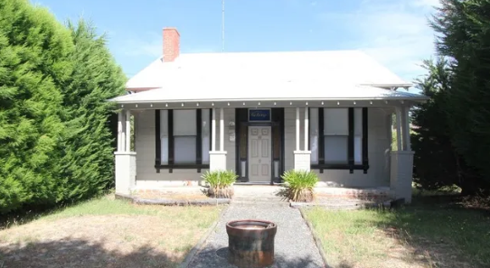 | Victory House is of local historical, social and associative significance.  Historically, Victory House illustrates the importance of mining to the locality of Canadian, and more broadly the City of Ballarat. The house has strong associations with Ballarat’s Chinese community, which is comprised of those who are descended from, or have associations with Chinese migrants who settled in Ballarat. The Canadian Gully, where the subject land is located is one of the earliest and richest areas within the Ballarat Goldfields. The place has strong associations with the Chung family, who built the c.1906 residence and held the property within the family for over 100 years (until 2008) and made a strong contribution to the local Chinese and broader Ballarat community, particularly in the Twentieth Century. | - Victory House (dwelling) constructed c.1906 with c.1925 alterations (roof and verandah).  - Mature Cypress hedges.  - Areas of archaeological potential associated with the c.1882 Hardy residence, the 1906 residence, garden elements and outbuildings. | Internal alterations  No.  External paint controls  No.  Tree controls  Mature Cypress Hedges.  Outbuilding/Fence controls  No.  Prohibited uses allowed?  No.  Outbuilding/fence controls  No. | The property boundaries are consistent with the original site boundary. This extent encompasses the mature Cypress hedges along the east boundary.
HO227 | ‘Bournedale’ Selkirk house and garden  618 Howitt Street, Ballarat North.  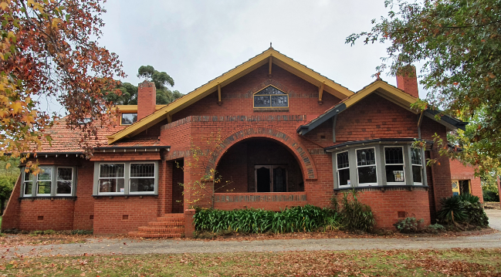 | ‘Bournedale’ house and garden are of local historical (associational), representative and aesthetic significance for its association with James Selkirk and the Selkirk Brickworks. James’ father, Robert Selkirk, began making bricks by hand in 1883 in Allendale, near Creswick.  Selkirk Brickworks, known under various names over the decades, was a major local manufacturer with a private railway siding and a Hoffman kiln. The house is of aesthetic significance as a fine and intact Arts & Crafts attic-storey bungalow of substantial size and fine craftsmanship, materials and detailing. The house, and auxiliary structures (front fence and garage) are significant for their association with the important Ballarat architectural practice P.S. Richards, Coburn & Richards, which was in existence from 1922 to 1932. The large, interwar suburban garden is of representative significance as the setting for the intact interwar house. The significance of the garden is enhanced by its relationship with the original house and for its retention of its original extent and key aspects of its interwar layout, plantings including several mature large trees and complementary shrubs, and the elaborate brick front fence and gates which echo the materials of the house. | - Bournedale’, the Selkirk house.  - The attached double garage, which retains timber sliding doors, at the north-east corner of the house,  - The front and east side garden layout, including the former tennis court, the materials (concrete) and form of the curved driveway and straight entry pathway, the brick front fence and gates, and spacious lawns.  - The mature specimen trees (the Cedar, Cottonwood, Copper Beeches, Liquidambars, Chinese Windmill Palms and Pin Oak), and shrubs, including the Highclere Holly. Other significant plantings including the three Hedge Maples (Acer campestre), the mature privet hedge, and the mature eucalypts at the rear of the property. | Internal alterations  No.  External paint controls  Retain clear finish on doors, screen doors, pictorial window, and ceiling strapping within front porch.  Tree controls  Yes. All mature specimen trees, shrubs, Palms and Privet hedge.  Prohibited uses allowed?  No.  Outbuilding/Fence controls  Yes. Brick fence, pedestrian and vehicle gates. | As significant plantings and garden elements are spread across the entire property, it is recommended that the Heritage Overlay polygon be applied to the entire extent of the cadastral boundaries.
HO228 | Miner’s Right/John Pearce House  89 Magpie Street, Golden Point.  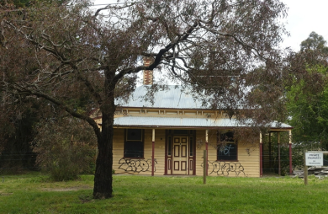 | The Miner’s Right/John Pearce House is of local historical, including associational, and representative significance. Historically, it illustrates the importance of mining in this area and is representative of houses built on miner’s rights and for mine managers during the late nineteenth century. It has significant associations with John Pearce, the son of John Pearce and Jane Bartle of Crowan, Cornwall, who immigrated to Victoria in the early 1850s. The extended Pearce family were active in mining and were representative of the significant Cornish migration in the nineteenth century to places such as Australia. The house also has significant associations with Peter and Janet Cuffley in 1972, who owned from 1972 to 1976. Peter Cuffley was appointed the first Curator of History at Sovereign Hill in 1972. | - The Miner’s Right/John Pearce House  - The north-east side verandah,  - The (formerly) detached kitchen. | Internal alterations  No.  External paint controls  No.  Tree controls  No.  Outbuilding/Fence controls  No.  Prohibited Uses allowed?  No. | A reduced Heritage Overlay polygon is recommended. It contains the house and land to the street frontage, and the side and rear residential garden in keeping with the fence lines in existence in 1958. This polygon is a rectangle following the south-east property boundary running for 66.5 metres, and 24 metres of the Magpie Street frontage.  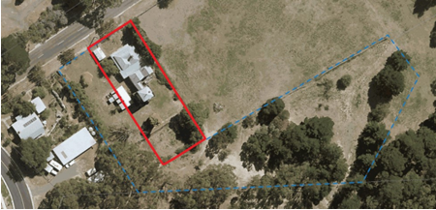
HO229 | Mossmont house and garden  1207 Winter Street, Buninyong  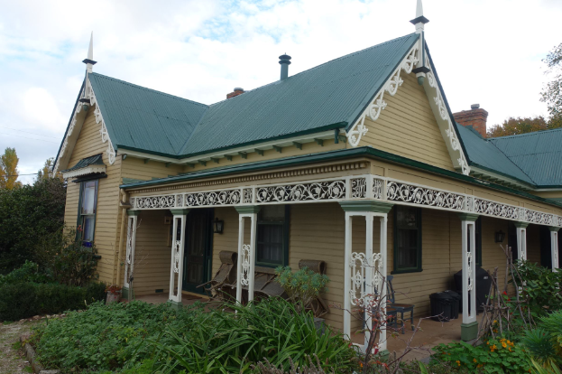 | Mossmont house and garden are of local historical (including associational) and aesthetic significance to the City of Ballarat. The house is aesthetically significant due to its verandah enrichments and bargeboards. It is historically significant for the evidence it provides of the earliest known nursery established in the Ballarat area, which was responsible for the supply of ornamental and fruit trees for the rapidly developing town and farms and, after they permanently reserved the land as Public Gardens in 1889, to the Buninyong Botanic Gardens. The place is significant for its historic association with Francis Moss, a notable figure in the early development of horticulture in Buninyong and the wider Ballarat area. The enlargement of the house in several stages, and the addition of embellishments, such as the later bargeboards, illustrate the growing prosperity of Francis Moss’s business. | - The early extent of the house constructed c1850s to c1922.  - The landscape setting.  - Remnants of the early drive from the northeast corner of the property to the house.  - Early plantings: mature elm (Ulmus sp) close to the house (northwest), mature Holly in the turning circle garden bed, early plantings along the length of the former drive including six Cherry Plum trees (purple and green foliaged varieties), a Liriodendron, and three Hawthorns.  - The brick outbuilding on the south side of the house is a contributory element of the site. | Internal alterations  No.  External paint controls  No.  Tree controls  Yes. Mature elm (Ulmus sp) mature Holly, early plantings along the length of the former drive including six Cherry Plum trees (purple and green foliaged varieties), a Liriodendron, and three Hawthorns  Prohibited Uses allowed?  No.  Outbuildings/fence controls  Yes. The brick outbuilding on the south side of the house is a contributory element. | The extent of the Heritage Overlay boundary includes the property boundaries, three of which (east, south, west) are consistent with the original site boundary. Although reduced from its original extent, this would enable appreciation of the dwelling set in a landscaped setting as it would have been during the operation of Mossmont as a nursery from the 1850s and nursery with pleasure garden by the 1870s.
HO230 | St Mark’s Anglican Parsonage  201 Melbourne Road, Brown Hill  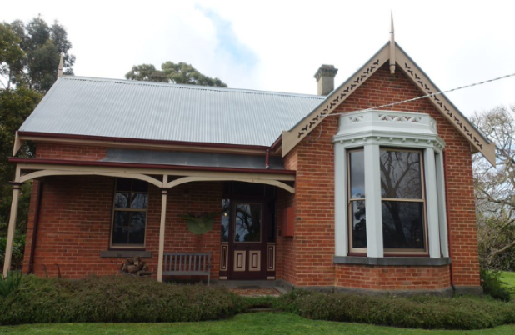 | The former St Mark’s Parsonage is of local historical, technical and aesthetic significance. The former parsonage illustrates the early development of Brown Hill and the efforts of the local Anglican community to establish their infrastructure including housing for their minister. The former parsonage is an early example of cavity wall construction in the Ballarat area and in its generous hillside setting ringed by early tree avenue plantings creates an attractive composition that illustrates the rural origins of Brown Hill. | - The 1872-74 original extent of the brick house, and the c1890s addition to the south-east corner.  - The elevated setting, with views to the west to Ballarat Central, ringed by an avenue of mature Dutch Elm and English Oak trees planted prior to 1934. | Internal alterations  No.  External paint controls  No.  Tree controls  Yes. Avenue of Dutch Elm and English Oak trees.  Outbuilding/fence controls  No.  Prohibited uses allowed?  No. | The property boundaries, three of which (west, north, south) are consistent with the original site boundary. This extent encompasses the avenue of trees, along the south and west boundaries.
HO231 | Holmes Street Residential Precinct  Ballarat Central  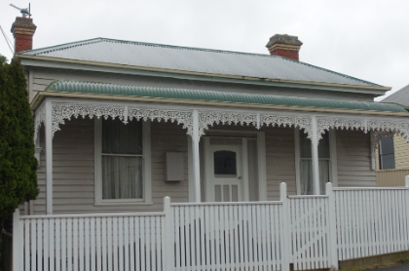  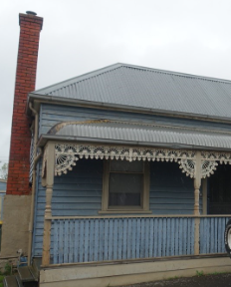  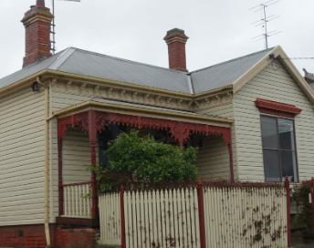  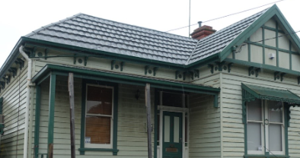  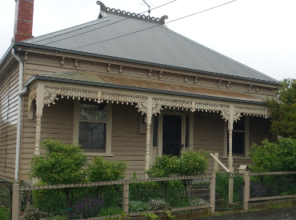  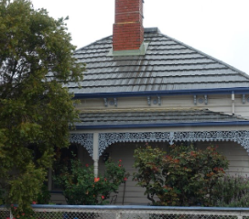 | The Holmes Street Residential Precinct is of local historical and aesthetic significance. Historically, the precinct illustrates the type small-scale speculative residential development that was typical prior to the advent of large-scale private developers in the early post-war years such as A.V. Jennings or local developer Roy Waller.  Aesthetically, the precinct is distinguished by its high level of visual intactness to its creation in the Edwardian period, making it a relatively rare grouping in a city mostly characterised by very heterogenous streetscapes. | - The c1870s houses, constructed by Jonathan Thompson, at 11 and 19 Holmes Street, including elements added in the Edwardian era such as chimneys and verandah detail  - The Edwardian houses, constructed by William Coltman from 1903-10, at 7, 9, 13, 15 and 17 Holmes Street  - The bluestone kerbs and spoon drains on both sides of Holmes Street. | Internal alterations  No.  External paint controls  No.  Tree controls  No.  Outbuilding/fence controls  No.  Prohibited Uses allowed?  No. | The precinct should encompass all properties at 7-19 Holmes Street to their cadastral boundaries, as well as the adjacent road reserves encompassing bluestone kerbs and channels on both sides of the street.

